
DEPARTMENT OF ARTIFICIAL INTELLIGENCE AND MACHINE LEARNING

PROBLEM SOLVING – GROUP 1
(USN ending with 0, 3, 5, 7)

Course: Computer Architecture Course code:25AIM34
Sem / Sec:III E Max. Marks: 15
Release Date:22/10/2026 Due Date:29/10/2026

1. Develop a Python program to add and subtract signed integers using 8-bit 2’s complement representation. Verify the following expressions:
(a) (+20) + (+15)
(b) (−20) + (−15)
For each expression, display the operands in 8-bit 2’s complement binary format, perform the operation, and display the result in binary and decimal formats. State whether arithmetic overflow occurs. Check the results using manual binary calculations.
Program:
def to_twos_comp_8bit(val: int) -> int:
return val & 0xFF
def to_binary_str(val: int) -> str:
return f"{to_twos_comp_8bit(val):08b}"
def to_signed_decimal(val: int) -> int:
val = val & 0xFF
return val - 256 if val >= 128 else val
def add_8bit(a_dec: int, b_dec: int):
a_bin = to_twos_comp_8bit(a_dec)
b_bin = to_twos_comp_8bit(b_dec)
carry = 0
carry_into_msb = 0
carry_out_msb = 0
result_bits = []
for i in range(8):
bit_a = (a_bin >> i) & 1
bit_b = (b_bin >> i) & 1
if i == 7:
carry_into_msb = carry
s = bit_a ^ bit_b ^ carry
carry = (bit_a & bit_b) | (carry & (bit_a ^ bit_b))
result_bits.append(str(s))
carry_out_msb = carry
result_bin = int("".join(reversed(result_bits)), 2)
overflow = bool(carry_into_msb ^ carry_out_msb)
return {
"op_a_bin": to_binary_str(a_bin),
"op_b_bin": to_binary_str(b_bin),
"res_bin": to_binary_str(result_bin),
"res_dec": to_signed_decimal(result_bin),
"expected_dec": a_dec + b_dec,
"carry_out": carry_out_msb,
"overflow": overflow,
}
def sub_8bit(a_dec: int, b_dec: int):
return add_8bit(a_dec, -b_dec)
def display_verification(label: str, a: int, b: int, is_subtraction: bool = False):
symbol = "-" if is_subtraction else "+"
res = sub_8bit(a, b) if is_subtraction else add_8bit(a, b)

print(f"=== Expression {label}: ({a:+d}) {symbol} ({b:+d}) ===")
print(f" Operand A: {res['op_a_bin']} ({a:+d})")
print(f" Operand B: {res['op_b_bin']} ({b:+d})")
print(f" Carry-Out: {res['carry_out']}")
print(f" Result Bin: {res['res_bin']}")
print(f" Result Dec: {res['res_dec']}")
print(f" Overflow: {'YES (Arithmetic Overflow)' if res['overflow'] else 'NO'}")
print()
display_verification("(a)", 20, 15)
display_verification("(b)", -20, -15)

Output:
PS C:\Users\Latitude\Desktop\computer architecture> & D:/development/anaconda/python.exe "c:/Users/Latitude/Desktop/computer architecture/1.py"
=== Expression (a): (+20) + (+15) ===
Operand A: 00010100 (+20)
Operand B: 00001111 (+15)
Carry-Out: 0
Result Bin: 00100011
Result Dec: 35
Overflow: NO

=== Expression (b): (-20) + (-15) ===
Operand A: 11101100 (-20)
Operand B: 11110001 (-15)
Carry-Out: 1
Result Bin: 11011101
Result Dec: -35
Overflow: NO
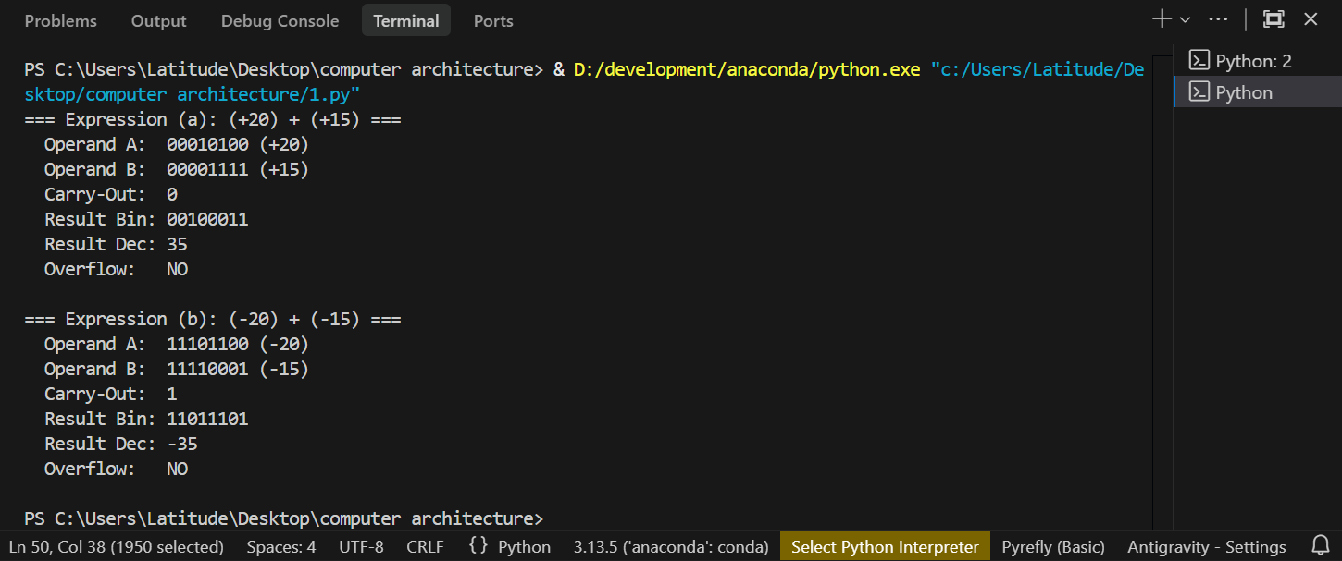
Manual Binary Calculation:
+20₁₀=16+4=00010100₂
+15₁₀=8+4+2+1=00001111₂
Carries: 0 0 0 1 0 0 0 0
0 0 0 1 0 1 0 0 (+20)
+ 0 0 0 0 1 1 1 1 (+15)
Sum: 0 0 1 0 0 0 1 1
00100011₂=2⁵+2¹+2⁰=32+2+1=35₁₀
Conclusion:
Both operations yield valid, mathematically accurate results that fit within the 8-bit signed range of [−128,+127] without any arithmetic overflow (V=0), confirming that (+20)+(+15)=+35 and (−20)+(−15)=−35

2. Write a Python program to perform floating-point subtraction using binary representation. Calculate (a) 1.5 − 0.25. Convert each number to binary, align the binary points, subtract the significands, and express the final answer in binary and decimal. Show the steps clearly.
Program:
def to_binary_8bit(val: int) -> str:
return f"{val & 0xFF:08b}"
def logical_left_shift_8bit(bin_str: str, positions: int = 2):
print(f"--- Logical Left Shift (<< {positions}) ---")
print(f"Initial 8-bit Binary: {bin_str} (Decimal: {int(bin_str, 2)})")
current = bin_str
for step in range(1, positions + 1):
discarded_msb = current[0]
current = current[1:] + "0"
print(f"Step {step}: Discard MSB '{discarded_msb}', Append '0' at LSB -> {current} (Decimal: {int(current, 2)})")
print(f"Final 8-bit Result: {current} (Decimal: {int(current, 2)})\n")
return current
def logical_right_shift_8bit(bin_str: str, positions: int = 2):
print(f"--- Logical Right Shift (>> {positions}) ---")
print(f"Initial 8-bit Binary: {bin_str} (Decimal: {int(bin_str, 2)})")
current = bin_str
for step in range(1, positions + 1):
discarded_lsb = current[-1]
current = "0" + current[:-1]
print(
f"Step {step}: Discard LSB '{discarded_lsb}', Prepend '0' at MSB -> {current} (Decimal: {int(current, 2)})"
)

print(f"Final 8-bit Result: {current} (Decimal: {int(current, 2)})\n")
return current
print("================ 8-BIT SHIFT OPERATIONS ================\n")
res_a = logical_left_shift_8bit("10110110", 2)
res_b = logical_right_shift_8bit("11010100", 2)

output:
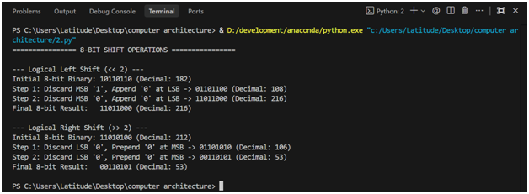

Manual Binary Calculation:
0 1 1 0 1 1 0₂ =Decimal value:128 + 32 + 16 + 4 + 2 = 182₁₀
Shift 1:
11010100 ₂01101010₂

Shift 2:
01101010₂0011010₂

Conclusion:
The step-by-step manual shifts perfectly match standard register behavior and integer arithmetic, producing 110110002​ (21610​) for the 2-bit left shift via modular multiplication and 001101012​ (5310​) for the 2-bit right shift via floor division.

